Create a cloud spanner instance .

Create database in spanner

Create table / schema

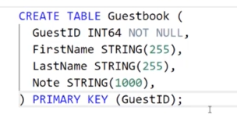

Insert data to table .

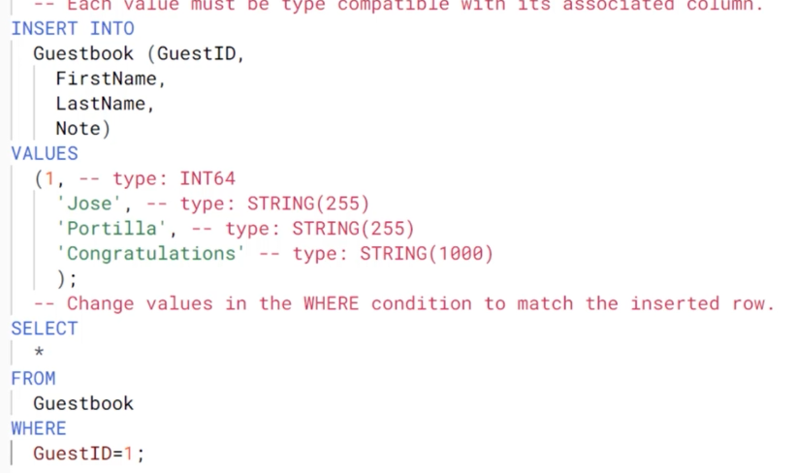

Run query .